SQL DEVELOPER INTERNSHIP
Week 3 Report
SQL Query Optimization and Performance Tuning
Virtual retail database on PostgreSQL (schema retail)
Submitted by: Vipul Janardan Patil
Submission date: 2 November 2026
Database engine: PostgreSQL 16.15 (reproduction run) and the PostgreSQL instance behind the supplied execution plans
Companion files: performance-comparison.csv, SQL scripts 01 to 08, README.md

1. Executive Summary
Week 3 tunes the retail database built in Week 1 (data model) and loaded in Week 2 (ETL plan). A synthetic PostgreSQL database of 870,500 rows (200,000 orders and 600,000 order items are the largest tables) was queried with and without the optimizations, and every claim below is tied to an execution plan or a measured time.
Two evidence sets are used and kept separate. Environment A is the set of four execution plans collected on my own PostgreSQL instance (single runs, node-level actual time). Environment B is a full reproduction of the Week 3 scripts on PostgreSQL 16.15 using script 08_run_benchmarks.py: one discarded warm-up and five recorded runs per query, with the median reported. Times from the two environments are never compared with each other.
Headline results (Environment B, median of 5, warm cache):
- Customer order history: 11.073 ms to 0.014 ms (99.9% faster). Plan changed from a parallel sequential scan reading 1,845 buffers to an index scan on idx_orders_customer_date reading 7.
- Customer-order join: 11.856 ms to 0.051 ms (99.6% faster).
- Monthly delivered revenue: 20.462 ms to 6.742 ms (67.1% faster) using an Index Only Scan with 0 heap fetches.
- Date-range report on a partitioned table: 25.401 ms to 12.603 ms (50.4% faster); the plan scans only partition orders_p_2026.
- Delivered sales for 2026: 30.8% faster. Category browsing: 94.5% faster in percentage but only 1.1 ms in absolute terms.
- Not improved: low-stock inventory (-27.9%, noise-dominated, inconclusive), the year-filter rewrite on its own (5.6%, within run-to-run variation) and SELECT * versus a column list (microseconds, not significant). These are reported as they were measured.
Reading my own plans (Environment A): two of the four plans carry a cost of 10000000000.00, the signature of enable_seqscan = off. The estimated 1,000 rows versus 53,673 actual rows in the first plan is the default estimate PostgreSQL uses for a function applied to a column. The sargable rewrite (125.4 ms to 74.4 ms, 40.7%) and partition pruning (74.4 ms to 46.5 ms, 37.5%) both point in the favourable direction, but they are labelled provisional because each is a single run.

2. Internship Task Objectives
The Week 3 task is SQL query optimization and performance tuning on a virtual retail database. The objectives, and where each is addressed in this report, are:
# | Objective | Section
1 | Build a repeatable baseline of retail queries with execution plans | 7
2 | Apply evidence-based optimizations: composite, covering and partial indexes, sargable rewrites, narrow projection, range partitioning | 8
3 | Compare before and after using the same query logic, data and parameters, with median of at least five runs | 5, 9
4 | Interpret execution plans: scan types, estimated versus actual rows, cost versus time | 10
5 | Connect each optimization to a retail business rule and state its trade-offs | 8, 11, 13
6 | Deliver the report, scripts, CSV and GitHub project so the results can be reproduced | 15

Success criteria. The business result is identical before and after (checked by hashing the full result set for every like-for-like pair, all matched); plans and buffers are captured; medians are used; and any change that does not help is reported as such.

3. Retail Database Overview
The lab uses a dedicated schema named retail. It keeps the Week 1 entities (suppliers, customers, products, orders) and adds order_items and inventory so that realistic transactional and stock queries can be tested.
Week | Deliverable | How it supports Week 3
1: Data modeling | Retail relational model: customers, products, suppliers, orders; keys and normalization | Defines the entities and joins queried in the lab
2: ETL planning | Extraction, staging, transformation, validation and loading plan | Explains how validated data reaches the reporting and transactional tables
3: Performance tuning | Baseline plans, optimizations, repeated benchmarks | Makes retrieval and reporting over the same model efficient

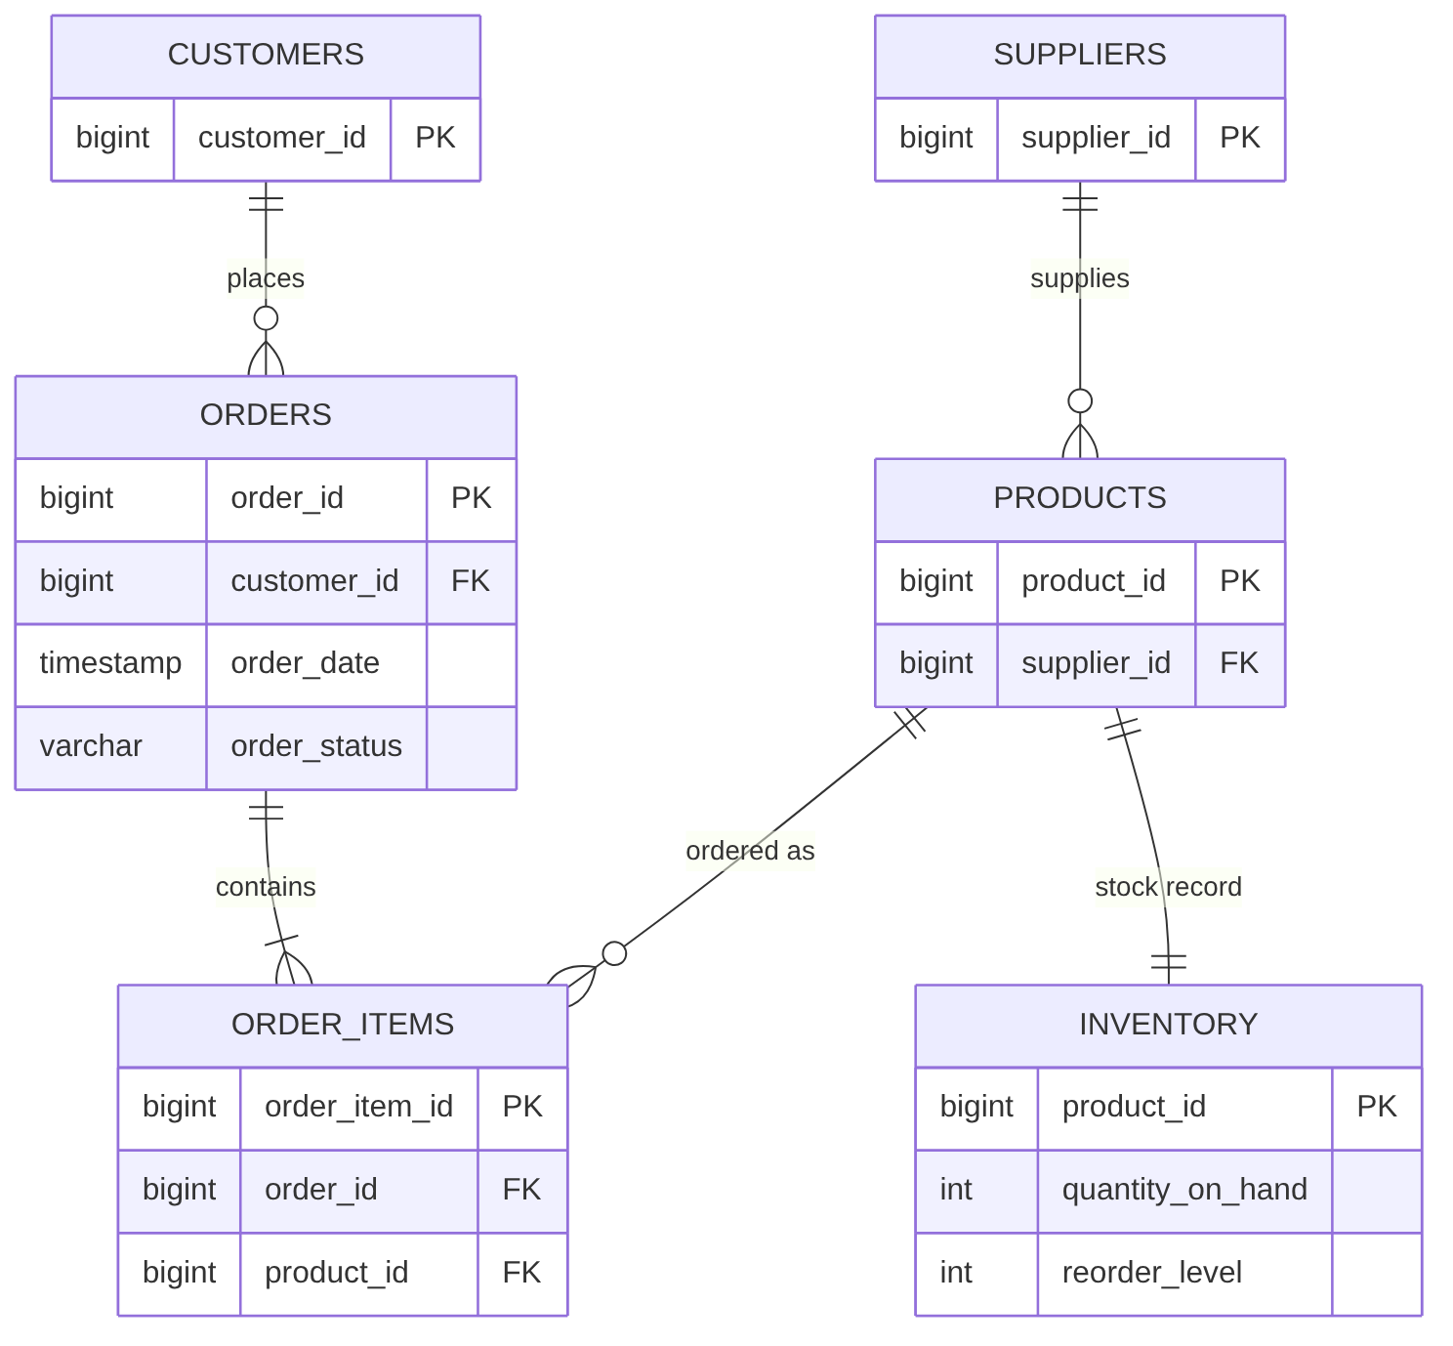
Figure 1: Entity relationships in schema retail
Table | Key columns | Integrity rules
suppliers | supplier_id (PK), supplier_name, city | Each product references one supplier
customers | customer_id (PK), email (UNIQUE), city, state | One customer places many orders
products | product_id (PK), supplier_id (FK), category, unit_price, is_active | unit_price >= 0
orders | order_id (PK), customer_id (FK), order_date, order_status, order_total | status in PLACED, PROCESSING, SHIPPED, DELIVERED, CANCELLED; total >= 0
order_items | order_item_id (PK), order_id (FK), product_id (FK), quantity, unit_price, line_total (generated) | quantity > 0
inventory | product_id (PK, FK), quantity_on_hand, reorder_level | Both >= 0; one row per product

At baseline only primary keys, the customers.email unique constraint and foreign-key constraints exist. PostgreSQL does not automatically index the referencing side of a foreign key, so orders.customer_id has no index until 05_create_indexes.sql runs. This is exactly what makes the customer-history queries slow in the baseline.

4. Dataset and Record Counts
Counts below were verified with COUNT(*) after running 01_create_schema.sql and 02_generate_data.sql on PostgreSQL 16.15. All records are synthetic. Loading took about 15 seconds.
Table | Rows | Heap size | Generator facts verified
suppliers | 500 | n/a | 5 cities
customers | 50,000 | 5.4 MiB | unique email per customer
products | 10,000 | 768 kB | 1,666 Electronics, 1,600 of them active; 4% inactive overall
orders | 200,000 | 14.1 MiB (1,809 pages) | exactly 4 orders per customer; exactly 40,000 per status
order_items | 600,000 | 43.8 MiB | exactly 3 items per order
inventory | 10,000 | 512 kB | 840 rows (8.4%) at or below reorder level
Total | 870,500 | 137 MB database

- Date distribution. Order dates run from 2024-01-01 to 2026-09-26 (1,000 days). In the reproduction run, 53,710 orders fall in 2026 (26.9% of the table), of which 10,577 are DELIVERED. My own run returned 53,673 rows for the 2026 filter; the 37-row difference is expected because random() is not seeded.
- Partition sizes (script 07): before 2025 = 72,906; 2025 = 73,384; 2026 = 53,710; 2027 and later = 0. Total 200,000.
- Consequence for the queries. Customer 12345 and customer 23456 each own only 4 orders, so LIMIT 20 and LIMIT 25 never trigger. The benefit of the customer index is therefore the elimination of a 200,000-row scan, not a top-N shortcut.
- Known simplification. orders.order_total is generated independently of order_items; none of the 200,000 order totals equals the sum of its line totals. This does not affect the performance tests but should be fixed if the data is reused for revenue reconciliation.

5. SQL Optimization Methodology
Each experiment follows the same loop: define the business question, record a baseline, change one thing, re-measure the same query, and compare correctness, time and plan.

5.1 Measurement protocol
- Run ANALYZE after the load and again after every index or partition change; run VACUUM (ANALYZE) before index-only scan tests so the visibility map is current.
- Use EXPLAIN (ANALYZE, BUFFERS) and read Execution Time, scan node types, estimated versus actual rows and shared hit/read blocks.
- Run each query once as a discarded warm-up and then five recorded times with identical parameters. Report the median, not the best run. All runs are warm-cache (all reads were buffer hits; shared read blocks were 0).
- Hash the full result set for each before/after pair to prove the business result is unchanged.
- Never use SET enable_seqscan = off to prove an optimization. It is used once, in a diagnostic (Section 10), to explain my own plans.
- Improvement % = ((Before - After) / Before) x 100. Negative means slower. If either side is missing, no percentage is calculated.

5.2 The two environments
 | Environment A (my own instance) | Environment B (reproduction)
Source | Four execution-plan excerpts supplied with the task | 08_run_benchmarks.py run for this report
PostgreSQL | Not stated; plan format shows pre-18 disabled-plan cost (1e10) | 16.15 on Ubuntu 24.04, 2 vCPU, 8 GB RAM
Settings | Probably enable_seqscan = off for Plans 1 to 3 (inferred) | Defaults: shared_buffers 128MB, work_mem 4MB, 2 parallel workers per gather; jit = off
Runs | One run per plan; time is the node's actual total time | 1 warm-up + 5 recorded; median; Execution Time
Use in report | Plan interpretation; provisional pairs UP-01, UP-02 | All headline numbers BM-01 to BM-10

Environment B was run on 2 November 2026 on a cloud container, so absolute milliseconds will differ from my machine. The ratios, plan shapes and buffer counts are what transfer. Section 15 explains how to regenerate every number on any PostgreSQL instance.

6. Performance-Tuning Workflow Diagram
The workflow below is the process applied to every experiment. The loop back from "No" is important: an index or rewrite that does not give a correct, measurable benefit is revised or removed. BM-05 in this report is an example.
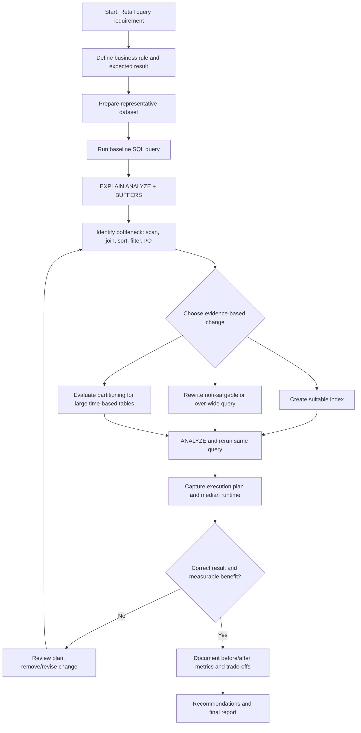
Figure 2: Performance-tuning workflow (source: diagrams/performance-tuning-flowchart.mmd)

7. Baseline Query Analysis
Baseline = only primary keys, unique and foreign-key constraints. Plans below are from Environment B (indexes absent). Buffers are 8 kB pages read from shared buffers.

B1 Customer order history
Business problem: Customer service needs the latest orders of one customer.
SELECT order_id, order_date, order_status, order_total
FROM orders
WHERE customer_id = 12345
ORDER BY order_date DESC
LIMIT 20;

Baseline plan: Gather Merge > Sort > Parallel Seq Scan on orders. 199,996 rows removed by the filter to return 4 rows; 1,845 buffers; median 11.073 ms. Every call scans the whole 14 MiB table.

B2 Product category browsing
Business problem: A shopper browses active Electronics products, alphabetically.
SELECT product_id, product_name, unit_price
FROM products
WHERE category = 'Electronics' AND is_active = TRUE
ORDER BY product_name
LIMIT 100;

Baseline plan: Seq Scan on products (8,400 rows removed, 1,600 kept) then top-N heapsort; 96 buffers; median 1.178 ms. The scan and sort repeat for every page view.

B3 Delivered sales for a year
Business problem: A manager reviews delivered orders of 2026, newest first.
SELECT order_id, customer_id, order_date, order_total
FROM orders
WHERE order_status = 'DELIVERED'
AND order_date >= TIMESTAMP '2026-01-01'
AND order_date < TIMESTAMP '2027-01-01'
ORDER BY order_date DESC;

Baseline plan: Parallel Seq Scan (189,424 rows removed, 10,577 kept) then Sort and Gather Merge; 1,845 buffers; median 20.864 ms. Estimate 6,182 versus 5,288 actual per worker (17% high).

B4 Customer-service join
Business problem: An agent needs a customer's recent orders plus contact details.
SELECT o.order_id, o.order_date, o.order_status,
c.first_name, c.last_name, c.email
FROM orders o
JOIN customers c ON c.customer_id = o.customer_id
WHERE o.customer_id = 23456
ORDER BY o.order_date DESC
LIMIT 25;

Baseline plan: Nested Loop: Parallel Seq Scan on orders (99,998 rows removed per worker) plus Index Scan using customers_pkey. The join side is already indexed; the orders filter is the bottleneck. Median 11.856 ms.

B5 Low-stock inventory
Business problem: Stock staff need products at or below their reorder level.
SELECT i.product_id, p.product_name,
i.quantity_on_hand, i.reorder_level
FROM inventory i
JOIN products p ON p.product_id = i.product_id
WHERE i.quantity_on_hand <= i.reorder_level
ORDER BY i.quantity_on_hand ASC;

Baseline plan: Hash Join of two Seq Scans, then Sort. Estimate 3,333 rows versus 840 actual (a column-to-column comparison gets PostgreSQL's default 1/3 selectivity). 160 buffers; median 2.424 ms.

B6 Year filter
Business problem: A report needs all orders of 2026.
-- original (non-sargable)
SELECT order_id, order_date, order_total
FROM orders
WHERE DATE_PART('year', order_date) = 2026;

Baseline plan: Gather > Parallel Seq Scan; estimate rows=1000 versus 53,710 actual (53.7x too low). 1,809 buffers; median 24.199 ms.

B7 Monthly delivered revenue
Business problem: Finance wants delivered revenue per month for 2026.
SELECT DATE_TRUNC('month', order_date) AS sales_month,
COUNT(*) AS delivered_orders,
SUM(order_total) AS revenue
FROM orders
WHERE order_status = 'DELIVERED'
AND order_date >= TIMESTAMP '2026-01-01'
AND order_date < TIMESTAMP '2027-01-01'
GROUP BY DATE_TRUNC('month', order_date)
ORDER BY sales_month;

Baseline plan: Seq Scan (189,423 rows removed) > Sort > GroupAggregate. Estimate 10,510 groups versus 9 actual. 1,809 buffers; median 20.462 ms.

8. Optimization Techniques
Each technique lists the business problem, the change, why it should help, what the plan proves, and the cost.

8.1 Composite covering index for customer order history (B1, B4)
Business problem: Looking up one customer scanned 200,000 orders.
CREATE INDEX idx_orders_customer_date
ON orders (customer_id, order_date DESC)
INCLUDE (order_status, order_total);

Why it helps: The equality column (customer_id) comes first and the sort column (order_date DESC) second, so PostgreSQL walks one small index range already in the required order. INCLUDE stores the two extra selected columns in the index.
Plan evidence: B1 now shows Index Scan using idx_orders_customer_date, 4 rows, 7 buffers instead of 1,845 and no Sort node. B4 shows a Nested Loop whose outer side uses the same index and whose inner side uses customers_pkey, 10 buffers. It is an Index Scan, not an Index Only Scan, because order_id is not stored in the index.
Trade-offs: The index is 10.7 MiB (11,206,656 bytes), 76% of the 14.1 MiB orders table. Every INSERT or UPDATE of customer_id, order_date, order_status or order_total must maintain it. Write overhead was not measured in this report; an INSERT benchmark with and without the index is the additional test required.
Retail use case: "Show my orders" in the app and the support agent's customer lookup run thousands of times a day; a per-call saving of about 11 ms (BM-01) and 11.8 ms (BM-04) multiplies directly.

8.2 Composite index for category browsing (B2)
Business problem: Every category page scanned and sorted the whole catalog.
CREATE INDEX idx_products_category_active_name
ON products (category, is_active, product_name);

Why it helps: Two equality columns then the sort column. PostgreSQL reads the first 100 matching entries already ordered by name and stops.
Plan evidence: Index Scan using idx_products_category_active_name, 100 rows, 28 buffers, no Sort node (before: Seq Scan, 8,400 rows removed, top-N heapsort, 96 buffers).
Trade-offs: Index is 432 kB. The saving is 1.1 ms because the catalog has only 10,000 rows; at 1,000,000 products the same pattern would matter far more, but that was not tested.
Retail use case: Customer-facing product listing where response time affects conversion.

8.3 Covering index for delivered-sales reports (B3, B7)
Business problem: Revenue reports re-scanned every order to find DELIVERED rows in one year.
CREATE INDEX idx_orders_status_date
ON orders (order_status, order_date DESC)
INCLUDE (customer_id, order_total);

Why it helps: Equality on status then a range on date gives one contiguous index range. For B7, every column the query touches (status, date, total) is inside the index, so the heap need not be visited.
Plan evidence: B7: Index Only Scan using idx_orders_status_date, Heap Fetches: 0, 85 buffers versus 1,809. B3: Bitmap Index Scan then Bitmap Heap Scan (1,807 heap blocks) and a Sort. B3 cannot be index-only because it also selects order_id, which is not in the index. Adding order_id to INCLUDE is a reasonable next experiment but was not tested.
Trade-offs: The index is 11.4 MiB (11,952,128 bytes). Index-only scans depend on VACUUM keeping the visibility map current; without it Heap Fetches rises and the benefit shrinks.
Retail use case: Month-end sales dashboards and delivered-revenue reconciliation.

8.4 Partial index for low-stock monitoring (B5)
Business problem: Inventory staff query a small subset (8.4%) of the stock table repeatedly.
CREATE INDEX idx_inventory_low_stock
ON inventory (quantity_on_hand, product_id)
WHERE quantity_on_hand <= reorder_level;

Why it helps: The index only contains rows that satisfy the business rule, so it is tiny and exactly matches the query predicate.
Plan evidence: The plan uses Bitmap Heap Scan via idx_inventory_low_stock and the inventory node time falls from 0.513 ms to 0.244 ms. However the whole query is dominated by the Seq Scan on products, the hash join and the sort, so the total did not improve reliably: median 2.424 ms before and 3.101 ms after (-27.9%), pulled up by one 10.508 ms outlier among the five after runs. The last-run plan texts show 2.549 ms and 2.392 ms. Conclusion: inconclusive at this table size; do not claim an improvement.
Trade-offs: The index is 48 kB, 9.4% of the 512 kB inventory table. Rows enter and leave it whenever stock changes, adding write cost. The estimate of 3,333 rows versus 840 actual shows PostgreSQL cannot see column-to-column selectivity.
Retail use case: Worth keeping only if inventory grows to hundreds of thousands of rows or the check runs very frequently. More runs (30 or more) are required to decide.

8.5 Sargable date-range rewrite (B6)
Business problem: DATE_PART('year', order_date) = 2026 hides the column inside a function.
-- original
WHERE DATE_PART('year', order_date) = 2026
-- rewritten: half-open range
WHERE order_date >= TIMESTAMP '2026-01-01'
AND order_date < TIMESTAMP '2027-01-01'

Why it helps: The range is a plain comparison on the column, so a B-tree on order_date can be used and the planner can estimate it from column statistics.
Plan evidence: The estimate improves from rows=1000 to rows=53,633 (actual 53,710). Execution time on its own did not change reliably: median 24.199 ms versus 22.840 ms (5.6%), and the five-run ranges overlap (22.6 to 26.2 ms versus 17.0 to 27.1 ms). Both plans are sequential scans and read 1,809 buffers.
Trade-offs: No storage cost. The benefit becomes real only when a suitable index exists (see 8.6).
Retail use case: Any yearly or monthly report: write >= start AND < next_start instead of EXTRACT/DATE_PART/DATE.

8.6 Range partitioning by order_date (partition experiment)
Business problem: Date-based reporting reads all years even when only 2026 is requested.
CREATE TABLE orders_partitioned (...) PARTITION BY RANGE (order_date);
CREATE TABLE orders_p_2026 PARTITION OF orders_partitioned
FOR VALUES FROM (TIMESTAMP '2026-01-01') TO (TIMESTAMP '2027-01-01');

Why it helps: A predicate on the partition key lets PostgreSQL skip partitions that cannot match (partition pruning).
Plan evidence: B9: Seq Scan on orders_p_2026, no other partition appears in the plan, 0 rows removed, 486 buffers versus 1,809; median 25.401 ms to 12.603 ms (50.4%). B10 repeats the test against a plain orders table that also has an order_date index (Bitmap Heap Scan, 1,958 buffers): 20.335 ms to 12.603 ms (38.0%). The partitioned plan is a sequential scan of the matching partition because 100% of that partition qualifies.
Trade-offs: Partitions, indexes, constraints and retention must be maintained; primary keys must include the partition key. The test only covers a whole-year range; narrow ranges were not tested and a B-tree on the plain table may do better there.
Retail use case: Archiving old years, dropping a partition instead of deleting millions of rows, and fast current-year reports.

8.7 Narrow projection (B8)
Business problem: SELECT * returns every column even when a screen needs three.
SELECT * FROM orders WHERE customer_id = 12345
ORDER BY order_date DESC LIMIT 20;
-- versus
SELECT order_id, order_date, order_status FROM orders
WHERE customer_id = 12345 ORDER BY order_date DESC LIMIT 20;

Why it helps: Less data moves between the engine and the application, and covering indexes become usable.
Plan evidence: Both versions use idx_orders_customer_date with 7 buffers and return 4 rows. Medians 0.028 ms and 0.009 ms differ by 19 microseconds, below reliable timer resolution, so no improvement is claimed. The result sets differ by design (different columns), so the result hash is not comparable here.
Trade-offs: None for performance; it is a coding-standard benefit.
Retail use case: API endpoints that return lists to mobile clients, where payload size matters more than server time.

9. Before-and-After Performance Comparison
Environment B, median of 5 recorded runs after one discarded warm-up. IDs follow BM-0n = baseline query Bn for n = 1 to 7; BM-08 to BM-10 are the projection and partition tests. All rows with a before/after result hash returned identical results (BM-08 is excluded by design).
ID | Scenario | Technique | Before (ms) | After (ms) | Saved (ms) | Improvement
BM-01 | Customer order history | Covering composite index | 11.07 | 0.014 | 11.06 | +99.9%
BM-02 | Category browsing | Composite index | 1.18 | 0.065 | 1.11 | +94.5%
BM-03 | Delivered sales 2026 | Covering composite index | 20.86 | 14.43 | 6.43 | +30.8%
BM-04 | Customer-order join | Composite index | 11.86 | 0.051 | 11.80 | +99.6%
BM-05 | Low-stock inventory | Partial index | 2.42 | 3.10 | -0.677 | -27.9%
BM-06 | Year filter rewrite | Sargable range | 24.20 | 22.84 | 1.36 | +5.6%
BM-07 | Monthly delivered revenue | Index Only Scan | 20.46 | 6.74 | 13.72 | +67.1%
BM-08 | SELECT * vs column list | Narrow projection | 0.028 | 0.009 | 0.019 | +67.9%
BM-09 | Partitioned vs plain | Range partitioning | 25.40 | 12.60 | 12.80 | +50.4%
BM-10 | Partitioned vs plain + index | Range partitioning | 20.34 | 12.60 | 7.73 | +38.0%

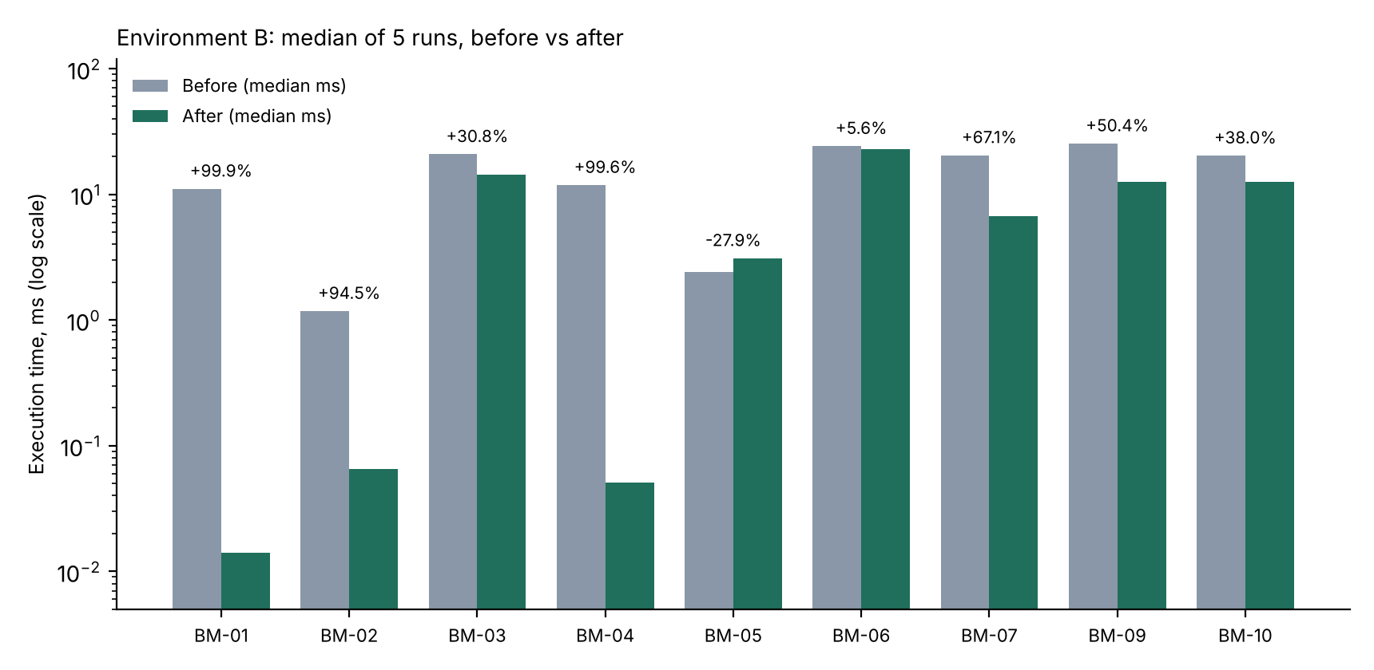
Figure 3: Median execution time before and after (log scale; BM-08 omitted as not significant)

9.1 Worked calculations
BM-01 (11.073 - 0.014) / 11.073 x 100 = 11.059 / 11.073 x 100 = 99.87% -> 99.9%
BM-07 (20.462 - 6.742) / 20.462 x 100 = 13.720 / 20.462 x 100 = 67.05% -> 67.1%
BM-09 (25.401 - 12.603) / 25.401 x 100 = 12.798 / 25.401 x 100 = 50.39% -> 50.4%
BM-05 (2.424 - 3.101) / 2.424 x 100 = -27.93% -> -27.9% (slower)
Buffers BM-01: 1,845 -> 7 (263 times fewer). BM-07: 1,809 -> 85 (21 times fewer).

9.2 Plan evidence and conclusion per benchmark
ID | Plan evidence | Conclusion
BM-01 | Parallel Seq Scan, 199,996 rows removed, 1,845 buffers, to Index Scan on idx_orders_customer_date, 7 buffers. | Large, confirmed gain.
BM-02 | Seq Scan, 8,400 rows removed, top-N heapsort, to Index Scan on idx_products_category_active_name, 28 buffers, no Sort. | Confirmed; small absolute saving at 10,000 rows.
BM-03 | Parallel Seq Scan, 189,424 removed, to Bitmap Index Scan on idx_orders_status_date then Bitmap Heap Scan (1,807 blocks) and Sort. | Moderate gain; not index-only because order_id is not included.
BM-04 | Nested Loop over Parallel Seq Scan to Nested Loop over Index Scan on idx_orders_customer_date, 10 buffers. | Large, confirmed gain; customers_pkey was already used.
BM-05 | Seq Scan on inventory to Bitmap Heap Scan on idx_inventory_low_stock; rest of plan unchanged. | Inconclusive. Median regressed from one outlier; more runs required.
BM-06 | Estimate rows=1000 to 53,633 (actual 53,710); both Seq Scans, 1,809 buffers. | Better estimate, no reliable time gain without an index.
BM-07 | Seq Scan + Sort + GroupAggregate to Index Only Scan, Heap Fetches 0, 85 buffers. | Confirmed gain; depends on VACUUM.
BM-08 | Both Index Scan on idx_orders_customer_date, 7 buffers. | Not significant.
BM-09 | Seq Scan on orders (146,290 removed) to Seq Scan on orders_p_2026 only, 486 buffers. | Pruning confirmed; 50.4% faster.
BM-10 | Bitmap Heap Scan on idx_orders_order_date_ctrl, 1,958 buffers, to Seq Scan on orders_p_2026, 486 buffers. | Partition still faster (38.0%) against an indexed plain table for a full-year range.

9.3 Pairs from my own plans (Environment A)
ID | Pair | Before (ms) | After (ms) | Improvement | Status
UP-01 | Year filter: Plan 1 (Seq Scan) to Plan 3 (Bitmap Heap Scan) | 125.4 | 74.4 | 40.7% | Provisional: single run, node time, scan types differ
UP-02 | Plain Plan 3 to partitioned Plan 4 (orders_p_2026) | 74.4 | 46.5 | 37.5% | Provisional: single run, index on base table unknown
UP-03 | Aggregation, Plan 2 only | 83.6 (node) | Not measured | Not calculated | No after-measurement supplied
UP-04 to 08 | Customer history, category, delivered sales, join, low-stock | Not measured | Not measured | Not calculated | Additional benchmark required
UP-01: (125.4 - 74.4) / 125.4 x 100 = 40.7%. UP-02: (74.4 - 46.5) / 74.4 x 100 = 37.5%. These are calculated from the actual times in the supplied plans, but the sources are single runs, so they are labelled provisional and are not mixed with the Environment B medians.

10. Detailed Execution-Plan Interpretation

10.1 The four supplied plans
# | Node | Cost (start..total) | Rows est. / actual | Actual time (ms) | Reading
1 | Seq Scan on retail.orders | 10000000000.00 ..  10000004809.00 | 1,000 / 53,673 | 0.200 ..  125.400 | Whole table read; filter keeps 26.8%; estimate 53.7x too low
2 | GroupAggregate | 10000006043.29 ..  10000006307.99 | 10,588 / 9 | 67.000 ..  83.600 | Sort-based aggregation; group estimate 1,176x too high
3 | Bitmap Heap Scan on retail.orders | 7485.76 ..  10095.28 | 53,368 / 53,673 | 25.700 ..  74.400 | Index bitmap then heap; estimate 0.6% low
4 | Bitmap Heap Scan on retail.orders_p_2026 | 1146.44 ..  2437.53 | 53,673 / 53,673 | 7.100 ..  46.500 | Only the 2026 partition touched; estimate exact

10.2 Plan 1: sequential scan
A Seq Scan reads every page of the table in order and tests each row. It is the right choice when most rows are needed or no useful index exists. Here retail.orders has about 200,000 rows and 26.8% of them (53,673) qualify. The cost 4809.00 is PostgreSQL's estimate in abstract units (page reads plus per-row CPU), not milliseconds. The 125.4 ms is measured. The two are only loosely related: cost ranks alternative plans; time is what the user waits.
Estimated versus actual rows. The planner expected 1,000 rows and got 53,673. A row estimate of exactly 1,000 for a 200,000-row table is 0.5%, the default PostgreSQL applies to an equality test on an expression it has no statistics for. This is the signature of DATE_PART('year', order_date) = 2026. The same query on the reproduction database printed rows=1000 too. The query text was not supplied with the plan, so the identification is an inference, supported by the matching row count (about 269 of the 1,000 generated days fall in 2026, giving roughly 53,800 expected rows) and by the identical cost 4809.00.
The 10000000000 in the cost. PostgreSQL versions before 18 add 1e10 to the cost of a node type that has been disabled. Running the same query here with SET enable_seqscan = off produced cost=10000000000.00..10000004809.00 rows=1000, identical to Plan 1. So Plan 1 was captured with sequential scans switched off. A Seq Scan still appeared because no index could answer the predicate, which confirms there was no usable index on order_date for that query at that moment. I should check with SHOW enable_seqscan; and reset it with RESET enable_seqscan; before collecting final timings.

10.3 Plan 2: group aggregation
GroupAggregate consumes rows already sorted by the grouping key and emits one row per group. It was fed by a sort of the delivered-order rows, which is why its start cost (6043.29) is almost its total cost (6307.99): nothing can be emitted until the sort finishes. The 1e10 prefix again comes from a disabled sequential scan underneath. The plan matches 04_rewrite_examples.sql (monthly delivered revenue): 9 groups are January to September 2026.
Estimate 10,588 versus 9 actual. PostgreSQL has no statistics for DATE_TRUNC('month', order_date), so it assumed almost every input row begins a new group. 10,588 is also close to 20% of the 2026 rows, the number of DELIVERED orders expected (the reproduction found 10,577). A correct estimate of 9 groups would make a HashAggregate plus a tiny sort attractive. Whether that would be faster was not measured; it is a hypothesis. Possible fixes to test: CREATE STATISTICS s ON DATE_TRUNC('month', order_date) FROM orders; or an expression index. In the reproduction, the covering index changed the scan to an Index Only Scan (6.7 ms median) while the group estimate stayed at 10,680, so the misestimate did not stop the improvement here.
Timing. 67.0 ms is when the first group was produced and 83.6 ms when the node finished, including the scan and sort below it. No before/after pair for aggregation was supplied from Environment A, so no percentage is calculated for it.

10.4 Plan 3: bitmap heap scan
A Bitmap Heap Scan is a two-step plan. First an index scan (a Bitmap Index Scan, not shown in the supplied excerpt) builds an in-memory bitmap of the heap pages that contain matches. Then the heap pages are read once each in physical order and the condition is rechecked. It sits between a plain index scan (few rows) and a sequential scan (most rows) and is typical when a few percent to a few tens of percent of the table qualifies. Here 53,673 of about 200,000 rows qualify (26.8%).
Which index? The excerpt does not show the child node, so it is not confirmed which index was used; only that some index was. Do not write an index name in the submission until the full plan shows it. The estimate is within 0.6% (53,368 versus 53,673), which is what the rewritten range predicate should give once column statistics are used.
Cost versus choice. Its total cost (10095.28) is higher than the 4809.00 of the sequential scan on the same table in Plan 1. A planner with all options enabled picks the lowest cost, so this bitmap plan was most likely chosen because sequential scans were disabled (enable_seqscan = off, see 10.2). In the reproduction, where nothing was disabled, a plain orders table with a matching order_date index chose a Bitmap Heap Scan at cost 3789 (cheaper than its sequential alternative) and a table without that index chose a Seq Scan. The lesson is that an index scan or bitmap plan is not automatically faster; the planner chooses by estimated cost.

10.5 Plan 4: partitioned table
The node is retail.orders_p_2026, aliased orders_partitioned. The plan has no Append over the other partitions, so partition pruning removed orders_p_before_2025, orders_p_2025 and orders_p_2027_plus at plan time. The estimate (53,673) equals the actual rows (53,673) because the 2026 partition holds exactly the rows being asked for and has its own statistics. A bitmap scan was used even though the whole partition matches; a sequential scan would normally be cheaper for 100% of a partition (as the reproduction chose, 486 buffers), so Plan 4 was probably also affected by disabled sequential scans.

10.6 Which comparisons are valid?
Comparison | Valid? | Reason
Plan 1 versus Plan 3 (UP-01) | Provisional | Same dataset and result size (53,673 rows); query identity for Plan 1 is inferred; single run; scan types differ; both likely under a disabled-seqscan setting
Plan 3 versus Plan 4 (UP-02) | Provisional | Same predicate and rows returned; different physical table and indexes; single run
Plan 2 versus any other | No | Different query (aggregate), no after plan
Estimated cost versus actual time | No | Cost is in abstract planner units; time is milliseconds
Environment A versus Environment B times | No | Different hardware, settings and cache state

10.7 Do the indexes and partitioning help?
- Indexing: yes, for selective lookups. BM-01 and BM-04 fall from about 11 ms to under 0.1 ms, buffers from 1,845 to 7 to 10, and the plans name the index used. BM-07 shows an Index Only Scan with 0 heap fetches.
- Indexing: limited for broad scans and tiny tables. BM-03 gains 30.8% because 5% of the table is returned and the heap is still read. BM-05 on a 10,000-row table is inconclusive.
- Partitioning: appears beneficial for full-year reporting. Both environments show pruning and lower time (UP-02 37.5% provisional; BM-09 50.4% and BM-10 38.0% as medians). The test did not cover narrow date windows, writes or maintenance cost.
- Rewrite alone: improves estimates, not necessarily time (BM-06).

11. Business Use Cases and Rules
Use case | Business rule | Query and technique | Measured effect (Env. B)
Customer order history | Return only the selected customer's orders, newest first | B1, covering composite index | 11.073 to 0.014 ms (99.9%)
Product browsing | Show only active products of the chosen category, alphabetical | B2, composite index | 1.178 to 0.065 ms (94.5%)
Delivered sales | Count only DELIVERED orders; cancelled orders are excluded | B3, B7, covering index | B3 30.8%; B7 67.1%
Customer-order join | Every order references an existing customer | B4, index on orders.customer_id | 11.856 to 0.051 ms (99.6%)
Low-stock inventory | Replenish when quantity_on_hand <= reorder_level | B5, partial index | Inconclusive (-27.9%)
Date-based reporting | Use half-open ranges so no timestamp is lost at year end | B6 rewrite, B9 partitioning | B6 5.6% (not significant); B9 50.4%

Worked retail example. A support agent opens customer 23456. Before tuning, the lookup scans 200,000 orders to find 4 rows: 11.856 ms and 1,832 buffers (BM-04). After idx_orders_customer_date, the same page needs 0.051 ms and 10 buffers. If the call centre handles 10,000 such lookups a day, the database time drops from about 119 seconds to about 0.5 seconds (10,000 x 11.856 ms = 118.6 s versus 10,000 x 0.051 ms = 0.51 s). This is arithmetic on the measured medians, not a measured production figure.

12. Results and Findings
- Missing foreign-key indexes dominated the cost. The two customer queries spent almost their whole 11 ms scanning 200,000 rows to return 4. One composite index removed 99.9% of that time.
- Covering indexes enable index-only scans, but only when every selected column is in the index. B7 qualifies (Heap Fetches 0); B3 does not because order_id is missing.
- Index size is a real cost. The two orders indexes occupy 23.2 MB (11,206,656 + 11,952,128 bytes), 156% of the 14.8 MB orders table.
- Not every optimization pays. BM-05, BM-06 and BM-08 did not produce a reliable gain and are reported that way.
- Estimates matter. Rows 1000 versus 53,673 (function on column), groups 10,588 versus 9 (expression), and rows 3,333 versus 840 (column-to-column comparison) all show where the planner is blind. Only the first was fixed by a rewrite.
- Partition pruning works as documented: the 2026 query touched one of four partitions and 486 of about 1,809 pages.
- Correctness preserved: the full result hash was identical before and after for BM-01 to BM-07, BM-09 and BM-10.

13. Limitations and Recommendations

13.1 Limitations
- The supplied Environment A data contains only four plans, with single runs and node-level times. No median could be computed from it.
- Environment B is a single 2-vCPU container with a warm cache and no concurrent load. It is evidence for this controlled exercise, not a production latency guarantee.
- Run-to-run variance is visible (for example BM-01 before: 10.7 to 16.8 ms; BM-05 after has a 10.5 ms outlier). Five runs are the minimum; more would narrow the uncertainty for small differences.
- Write overhead of indexes and partition maintenance was not measured. Cold-cache behaviour was not measured.
- The tables are small by production standards (14 MiB for orders). Gains for large scans, sorting and partitioning would differ at 100 times the size.
- The Plan 1 identification with the DATE_PART query and the "seq scan disabled" explanation are inferences from the plan shape and a reproduction; I should confirm the query text and the setting.
- Orders and order items are not consistent in the generator (totals differ).

13.2 Recommendations
- Keep idx_orders_customer_date; it gives the largest gain for the cost.
- Keep idx_orders_status_date if delivered-revenue reports run regularly; consider adding order_id to INCLUDE and re-test B3.
- Defer idx_inventory_low_stock until inventory is much larger; re-benchmark with 30 or more runs.
- Use half-open date ranges in every report query; add an order_date index or partitioning only if year-wide scans are frequent.
- Re-collect Environment A plans with RESET enable_seqscan; and five runs each, then replace UP rows with medians.
- Measure INSERT throughput with and without the indexes, and run the tests under concurrent load, before production use.
- Run VACUUM (ANALYZE) after bulk loads to keep index-only scans effective; refresh statistics after large changes.

14. Conclusion
Week 3 turns the Week 1 retail model and the Week 2 ETL plan into a measured performance exercise. With only keys and constraints, customer lookups and delivered-sales reports scanned the whole 200,000-row orders table. Targeted composite and covering indexes cut customer-history and customer-join queries by about 99.6% to 99.9% (11 to 12 ms to under 0.1 ms) and the monthly revenue aggregation by 67.1%, while partitioning reduced a full-year date report by 38.0% to 50.4% depending on the comparison. The same data show that a function-wrapped predicate misleads the planner (1,000 estimated versus 53,673 actual rows), that a partial index on a 10,000-row table was inconclusive, and that cost numbers such as 10000000000.00 can reveal a disabled planner setting rather than a real expense. The consistent lesson is to preserve the business result, read the plan, measure with medians and weigh index size and write cost.

15. Reproducibility Instructions

15.1 Run order
Script | Purpose and how to run
01_create_schema.sql | Creates schema retail and six tables. psql -d retaildb -f sql/01_create_schema.sql
02_generate_data.sql | Loads 870,500 synthetic rows (about 15 s) and runs ANALYZE
03_baseline_queries.sql | Baseline EXPLAIN (ANALYZE, BUFFERS, VERBOSE) for B1 to B7; save the output
04_rewrite_examples.sql | Year filter, SELECT * vs column list, monthly aggregation
05_create_indexes.sql | Creates the four optimization indexes, then ANALYZE
06_optimized_queries.sql | Same queries after indexing; compare with 03
07_partitioning_demo.sql | Creates orders_partitioned, loads it, checks pruning
08_run_benchmarks.py | Runs everything above automatically with 5 timed runs and writes results/benchmark_results.json and results/execution-plans/*.txt

15.2 Regenerating every number
createdb retaildb
psql -d retaildb -f sql/01_create_schema.sql
psql -d retaildb -f sql/02_generate_data.sql
pip install psycopg2-binary
python sql/08_run_benchmarks.py "host=localhost dbname=retaildb user=postgres" results

Before collecting your own plans run SHOW enable_seqscan; (must be on), and record SELECT version();, CPU, RAM, shared_buffers and the date. The script resets and recreates only the lab indexes and orders_partitioned, so it is safe to re-run. Replace the Environment A rows in performance-comparison.csv with your medians and update Sections 1, 9 and 10.

15.3 Checklist
- Counts match Section 4 (500, 50,000, 10,000, 200,000, 600,000, 10,000).
- Baseline plans saved before indexes exist.
- ANALYZE after load and after each index; VACUUM (ANALYZE) before B7.
- Five runs per query; median reported; enable_seqscan is on.
- Result hash identical for every before/after pair.
- CSV, report and README show the same figures.

Appendix A: Raw Run Data (Environment B)
Execution Time in ms for each of the five recorded runs, in order. The median is the middle value after sorting.
ID | Before runs | After runs | Buffers hit before to after
BM-01 | 13.437, 11.073, 10.855, 10.742, 16.757 | 0.012, 0.014, 0.013, 0.02, 0.036 | 1845 to 7
BM-02 | 1.178, 1.142, 1.188, 1.222, 1.119 | 0.086, 0.053, 0.065, 0.055, 0.067 | 96 to 28
BM-03 | 23.732, 20.332, 20.22, 20.864, 21.339 | 11.521, 11.619, 14.761, 14.65, 14.429 | 1845 to 1891
BM-04 | 12.332, 11.414, 11.328, 11.856, 12.481 | 0.06, 0.06, 0.041, 0.051, 0.044 | 1832 to 10
BM-05 | 2.422, 2.424, 2.605, 2.497, 2.342 | 3.101, 2.898, 10.508, 2.524, 3.534 | 160 to 165
BM-06 | 23.394, 22.627, 26.192, 24.818, 24.199 | 17.02, 17.911, 22.84, 25.608, 27.076 | 1809 to 1809
BM-07 | 22.702, 19.272, 20.241, 20.462, 21.385 | 8.6, 7.793, 6.714, 6.742, 6.088 | 1809 to 85
BM-08 | 0.024, 0.033, 0.028, 0.029, 0.025 | 0.013, 0.011, 0.009, 0.008, 0.008 | 7 to 7
BM-09 | 33.441, 25.401, 20.684, 18.359, 25.481 | 12.603, 12.493, 12.35, 12.827, 14.019 | 1809 to 486
BM-10 | 15.54, 17.695, 20.335, 22.444, 21.126 | 12.603, 12.493, 12.35, 12.827, 14.019 | 1958 to 486

Environment B: PostgreSQL 16.15 (Ubuntu 16.15-0ubuntu0.24.04.1) on x86_64-pc-linux-gnu; shared_buffers 128MB; work_mem 4MB; max_parallel_workers_per_gather 2; jit off; 2 vCPU; 8 GB RAM; run 2 November 2026. Full text plans are in results/execution-plans/.

